Prerequisite:

1. Setup Elasticsearch, Python, Python Flask in your machine
2. Insert the data from “sample_data.json” file to ES. You can use “Sense (Beta)” chrome plugin to feed the data.

**How to feed the data?**

Open your Sense extension and use POST request

Like: POST /hotels/hotel/hotel_list {data from file} and then click send request

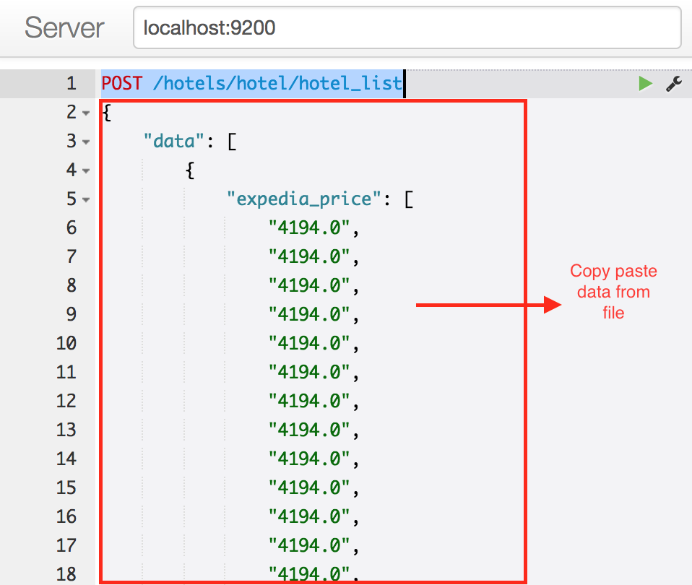

**How to run?**

1. Download and extract the project
2. Run the Elasticsearch
3. First run the flask project
4. Go to flask_project -> hello_flask
5. Type source bin/activate and then press enter
6. Run python app.py
7. Run the widget
8. Go to Chrome -> Extension
9. Click “Load unpacked extension” and select extension folder inside Hotel Price Comparison Widget folder

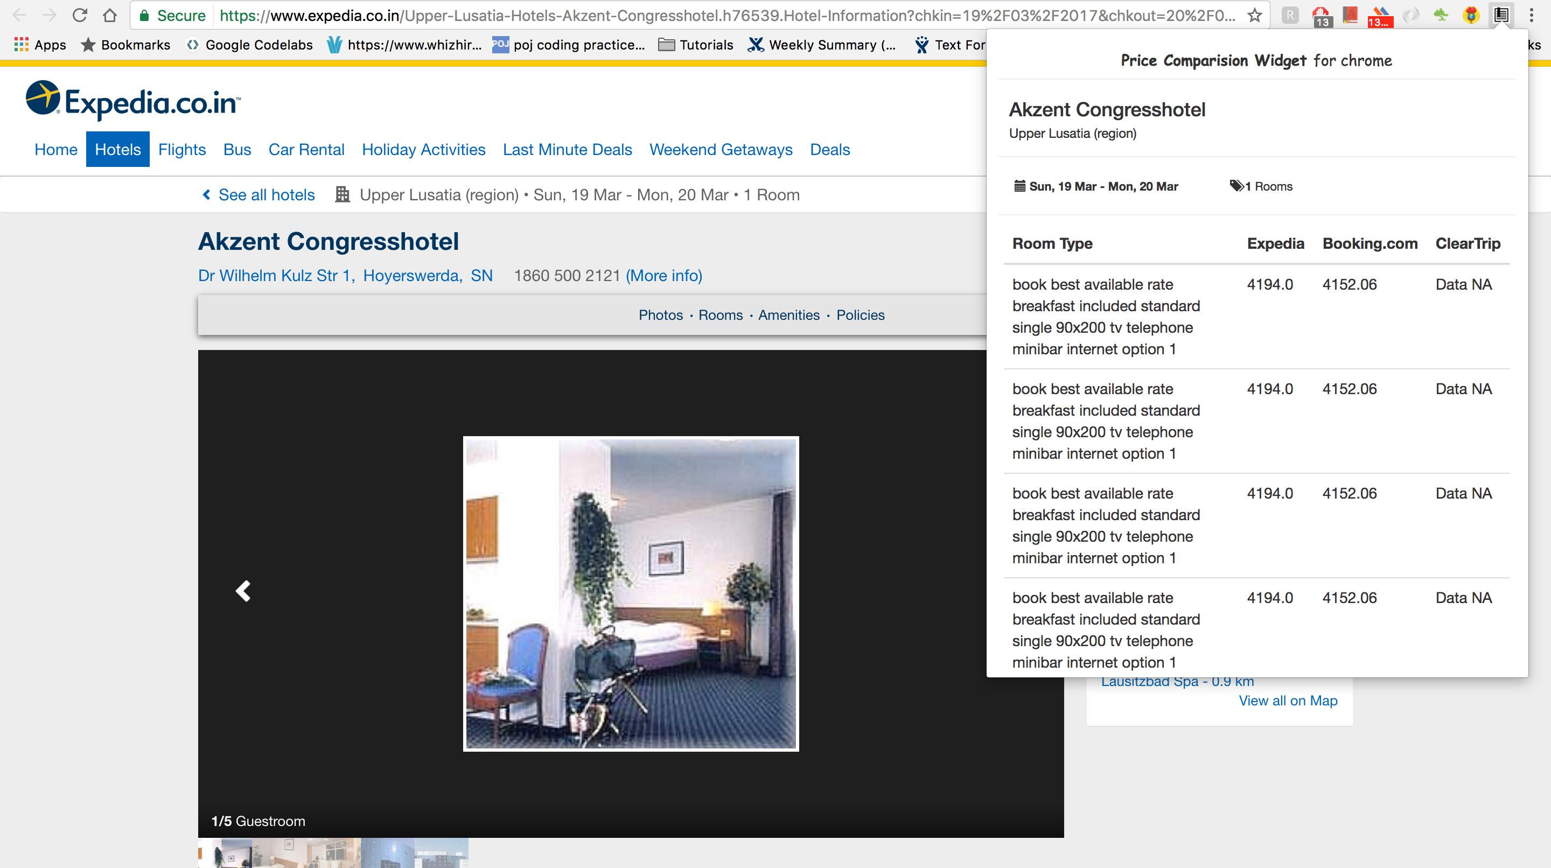

For this sample:

Search “Cottbus, Germany” in the expedia hotel search

Select checkin- checkout: 19-20 march

Number of room 1

And then open “Akzent Congresshotel”